|  |
| --- |
| IMAT 2103 – Progressive Game Engines |
| Lab 1: Setting up and Installing the Unreal Engine |

***Part 1:***

# Overview

In this exercise, you will practice creating a new project. You will create three new projects, each with a different Game Mode, and playtest the default Level.

# Outcome

Students will demonstrate their ability to install Unreal Engine 4.26 and load the Third-Person-Shooter Template

# Process

We will prepare our development environment.

Unreal Engine is free to download.

We will learn about how to install Unreal Engine 4 and create a new project.

After that, we will learn about some of the basic concepts of Blueprints and explore each panel of the Blueprint Editor.

1. **Installing Unreal Engine**

To use Unreal Engine, you must first install Epic Games Launcher:

1. Access the website: <https://www.unrealengine.com>
2. Register (using your student e-mail) and download Epic Games Launcher - you will need this to download free assets from the Unreal Marketplace.
3. Install and start the launcher
4. Click the Unreal Engine tab on the left-hand side
5. Click on the Library tab that appears at the top of the screen
6. Click the + button next to ENGINE VERSIONS to add a version of Unreal Engine to the launcher
7. Click the Install button
8. Click the Launch button to start an already installed version: (In DMU game labs, version 4.26.2 should have been previously installed).
9. 
10. It is possible to keep multiple versions of Unreal Engine.
11. **Creating new projects and using templates**
12. After starting up Unreal Engine Editor, a two-pane window will appear.
13. The Recent Projects pane is used to open existing projects and the New Projects Category pane is used to create a new project, as shown in the following screenshot.
14. The New Projects Category pane has templates that can be used for the creation of a project.
15. 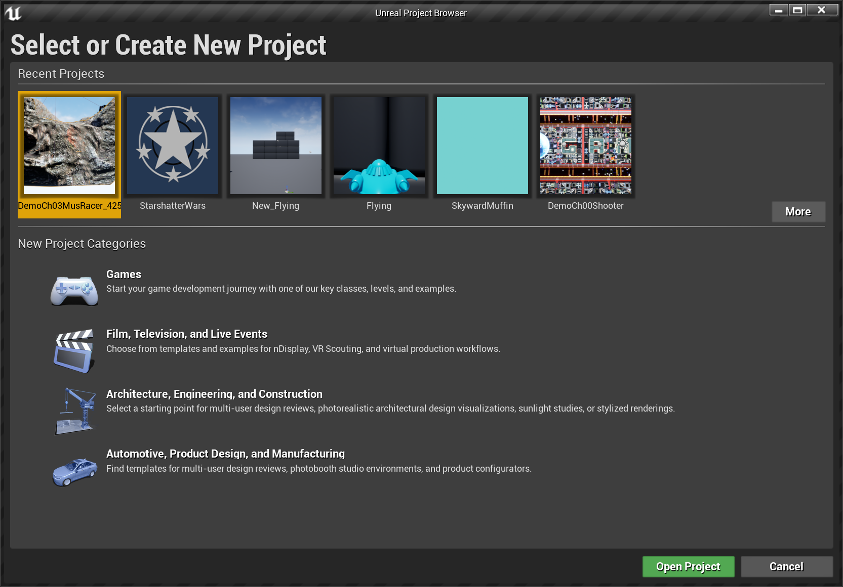
16. Select the Games Tab under New Projects Categories and click Next:
17. 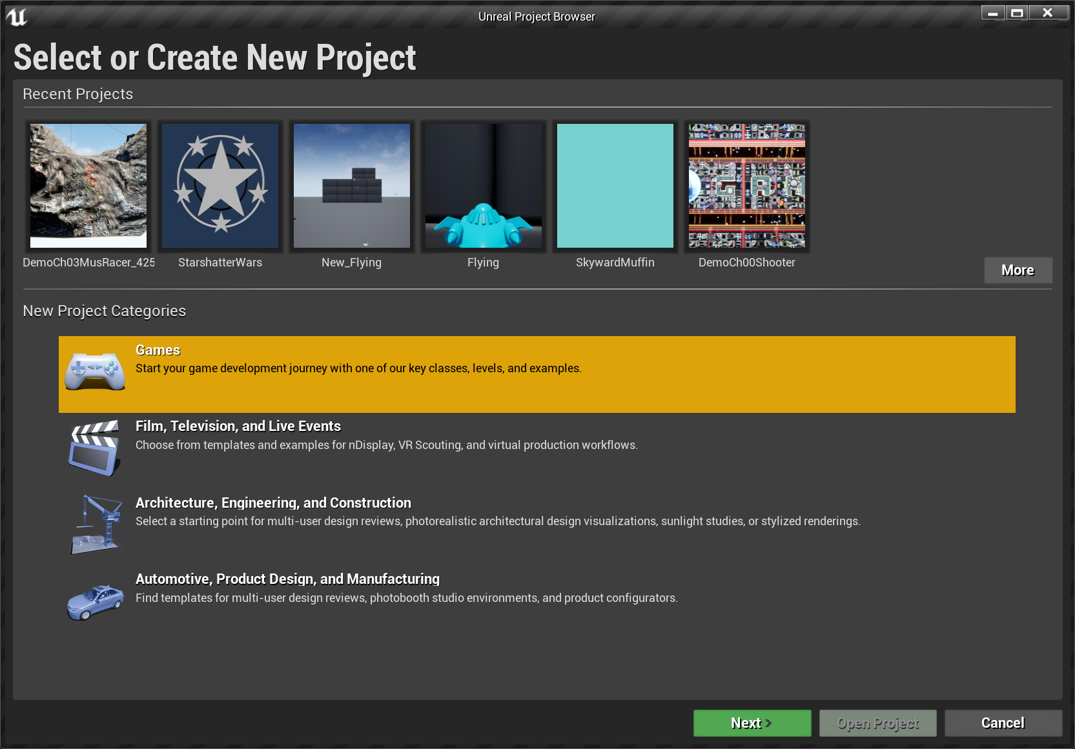
18. 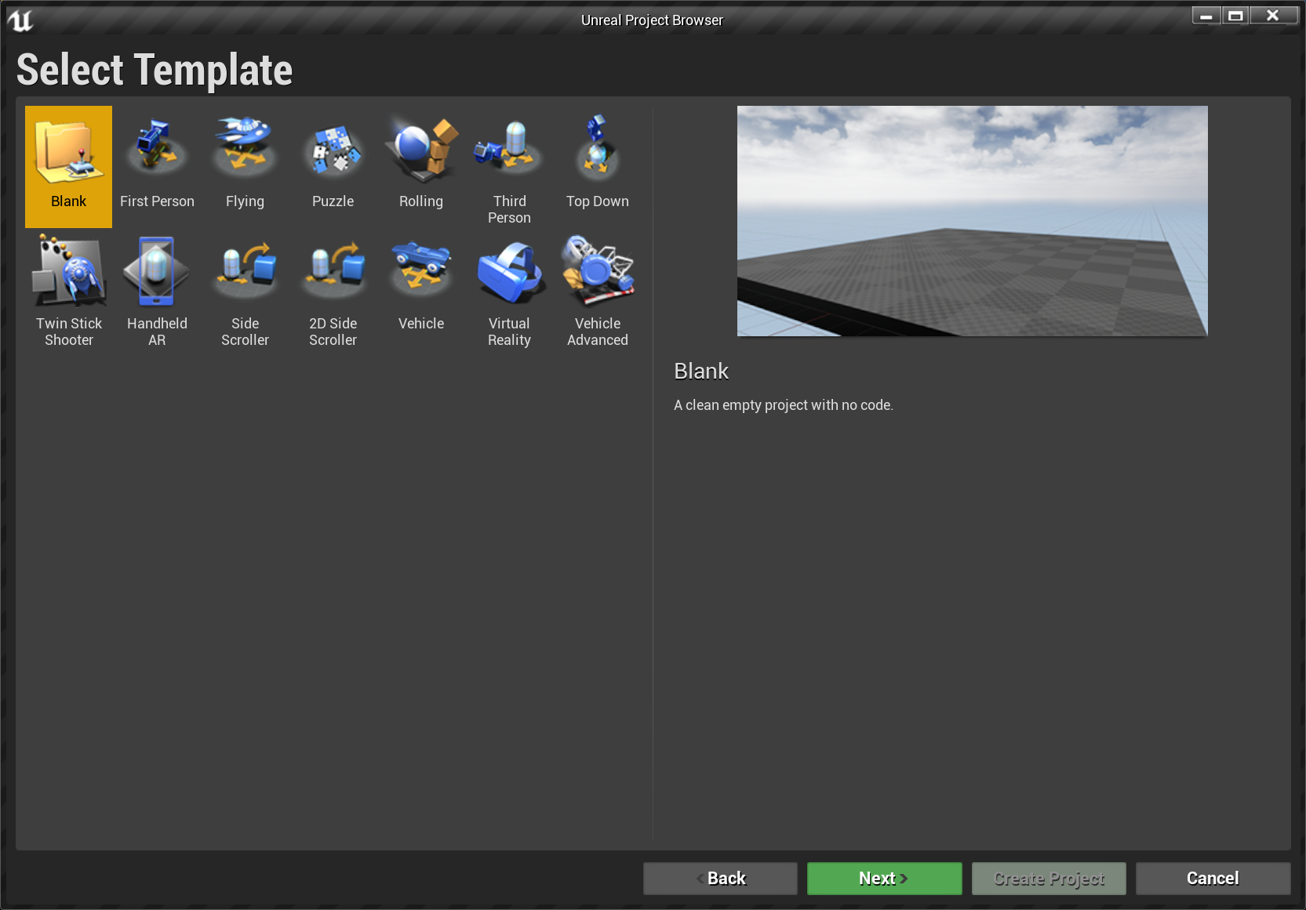

* Blank: An Empty project
* First Person: For games with a first-person perspective
* Flying: Contains a simple spaceship controlled by the player
* Handheld AR: For augmented reality applications
* Puzzle: For puzzle games using a mouse or touchscreen
* Rolling: Contains a physics-based rolling ball controlled by the player
* Side Scroller: For 3D side-scroller games
* 2D Side Scroller: For side-scroller games with 2D sprites
* Third Person: Contains a playable character with a camera that follows it
* Top Down: Contains a character controlled by a mouse with a camera at a great distance above it
* Twin Stick Shooter: Shows how to map the input to control movement and firing independently
* Vehicle: Contains a simple physics-driven vehicle controlled by the player
* Virtual Reality: Contains essential features for virtual reality games
* Vehicle Advanced: Contains a more complex vehicle with suspension

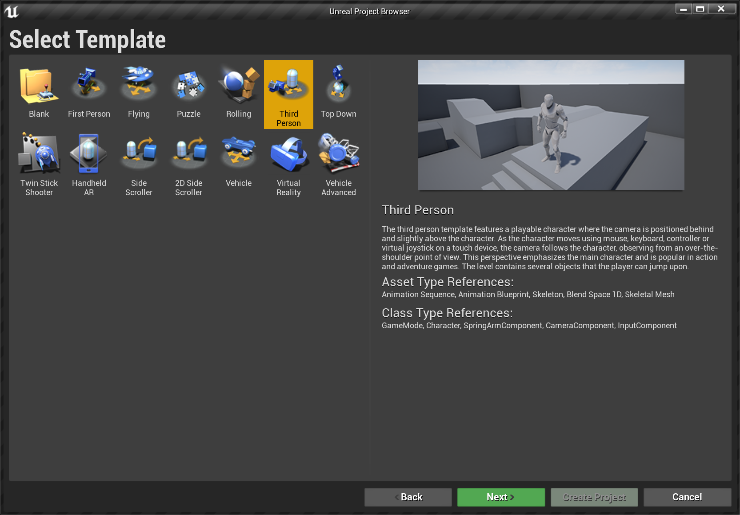

Select the Third-Person Template

1. There are three boxes with project configuration options. These options can be modified later in the project, and they are as follows:
2. Blueprint: There are templates made with Blueprint and templates made with the C++ programming language. In this module, we will be using blueprint projects.

* Target hardware: Desktop / Console or mobile/tablet. **CHOOSE DESKTOP**
* Graphical level: Maximum Quality or scalable 3D/2D. **CHOOSE MAXIMUM DETAIL**
* Starter content: With or without Starter Content. The starter content is a content pack with simple meshes, materials, and particle effects. The examples in this lab assume that the starter content is being used. **CHOOSE WITH STARTER CONTENT**
* Raytracing Disabled: Works with newer Nvidia RTX graphics cards. **CHOOSE RAYTRACING DISABLED**
* Location: Where the project will be stored. CALL THE PROJECT **IMAT2103-LAB1**

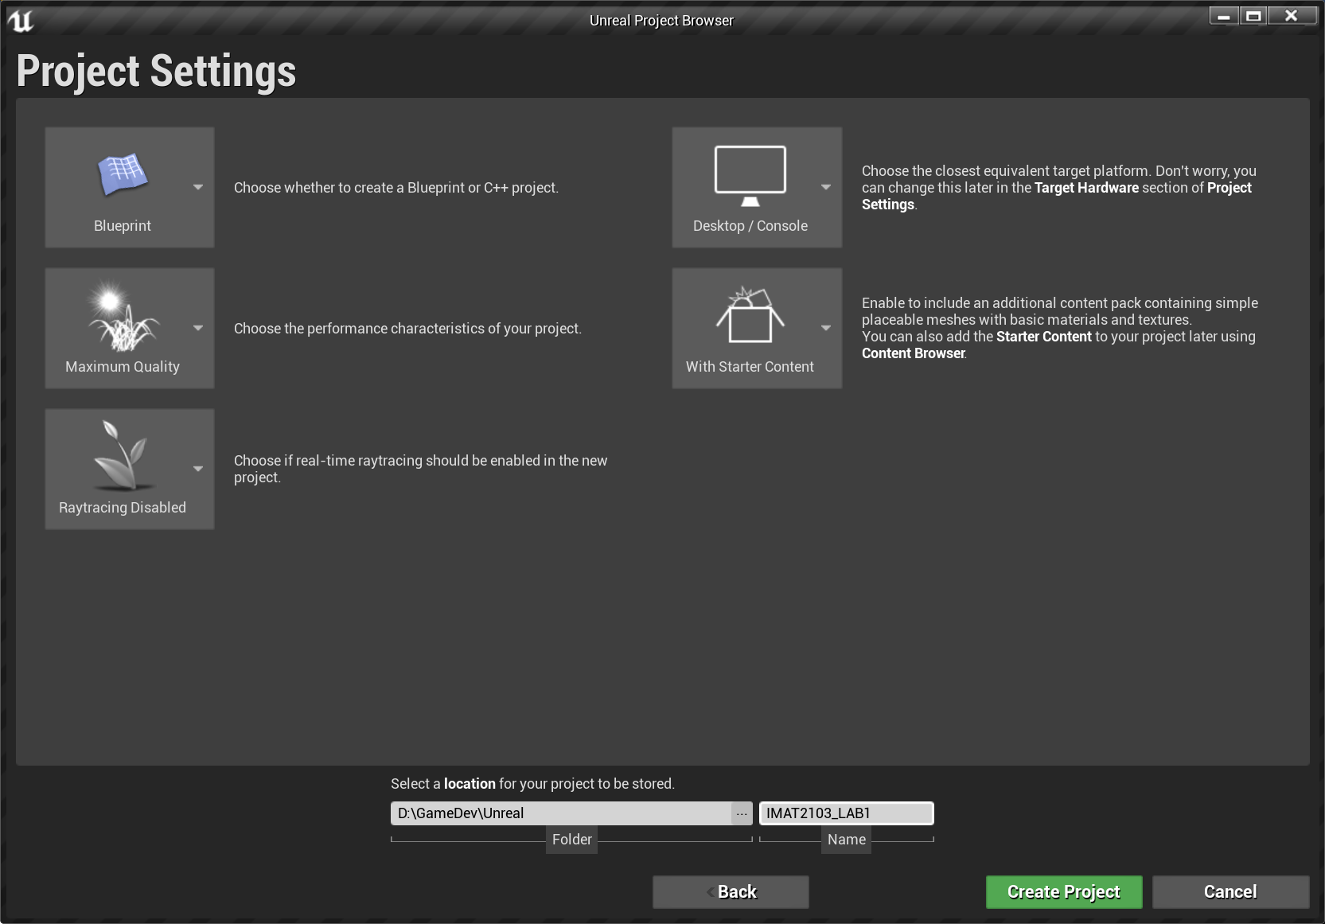

When set, click **on CREATE PROJECT**

**The Third-Person Project opens.**

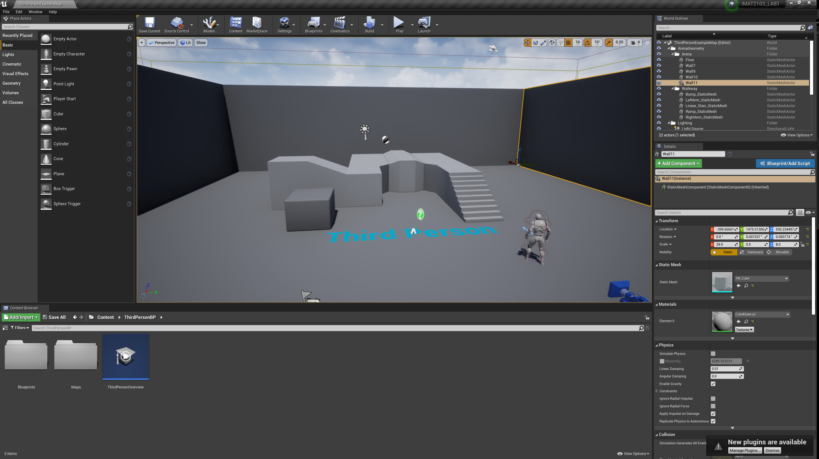

These are the key panels of the Level Editor:

1. Toolbar: Located at the top of the Level Editor. It contains buttons with commonly used operations. You can use it to save the Level, build the lighting, access other panels, and play the Level in the Editor.
2. Viewport: Located at the centre of the Level Editor. It shows the Level that is being created. You can use the Viewport panel to move around the Level and add objects on the Level.
3. Modes: Located to the left of the Level Editor, the Modes panel can be used to change the editing mode of the Level Editor for a specialized interface such as Landscape mode.
4. Content Browser: Located at the bottom of the Level Editor. It is used to manage the assets of the project. An asset is a piece of content of an Unreal Engine project. For example, Materials, Static Meshes, and Blueprints are all assets. If you drag an asset from Content Browser and drop it in the Level, the Editor creates a copy of the asset to place in the Level.
5. World Outliner: Located to the right of the Level Editor. It lists the objects that are in the Level.
6. Details: Located to the right of the Level Editor, below World Outliner. It shows the editable properties of an object that is selected in Viewport.

# Submission Requirements

Time for completion: 30–45 minutes

* Lecturer observation

***Part 2:***

# Overview

In this exercise, you will practice creating a new project. You will create three new projects, each with a different Game Mode, and playtest the default Level.

# Outcome

Students will demonstrate their ability to create a project and playtest a Level.

# Process

Create three new Blueprint-based projects with the following settings and playtest the default Level for each project.

Project 1

* Project name: MyProject_A
* Template: First Person
* Quality: Maximum Quality
* Starter content: Yes

Project 2

* Project name: MyProject_B
* Template: Third Person
* Quality: Scalable 3D or 2D
* Starter content: Yes

Project 3

* Project name: MyProject_C
* Template: Rolling
* Quality: Your choice
* Starter content: No

1. Present it to the class on discussion board.

# Submission Requirements

Time for completion: 20–30 minutes

1. Present it to the class on discussion board.

***Part 3:***

# Overview

In this exercise, you will download the Unreal Content Examples Project from the Learn section of the Epic Games Launcher.

# Outcome

Students will demonstrate their ability to use the Launcher to access the Content Examples Project.

# Process

1. Open the Epic Games Launcher and navigate to the Learn tab.
2. Locate the Content Examples Project.
3. Create a new project with the content example.
4. Open the project.
5. Playtest at least three of the example Levels.
6. In each Level, identify at least one example of something you did not know the engine could do.
7. Present it to the class on discussion board.

# Submission Requirements

Time for completion: 20–30 minutes

* Class discussion (on discussion board)